Exemplar: Evaluating data for transformation

Introduction
In the exercise Evaluating data for transformation, you were entrusted with the role of a data analyst for Adventure Works. You were required to evaluate and transform blocks of data from different datasets using Microsoft Excel.
More specifically, you were asked to:
- Evaluate and rectify inconsistencies within the Sales dataset, such as missing TransactionIDs and SalesAmounts, and textual entries in numeric columns.
- Analyze the Inventory dataset, handle missing ProductNames and Categories, and standardize RestockingFrequency.
- Review the Customer Feedback dataset, correct irregularities in FeedbackScores, fix erroneous dates, and handle missing feedback entries.
This reading provides you with a guide that you can use to compare to your own work.

Exemplar: Evaluating data for transformation
- You downloaded the Sales Data, Inventory Data, and Customer Feedback Data CSV files to your computer.
- You right-clicked the Sales Data CSV file and selected Open with > Excel.
- You repeated this process for the other two files. This opened the files in Excel.

Sales Dataset: What is the total sales value per product?

Step 1: Addressing Missing TransactionIDs
- The initial step in transforming sales data was to deal with missing TransactionIDs. These are key identifiers, and their absence can skew the overall analysis. To handle this, you first selected the TransactionID column header to select the column.
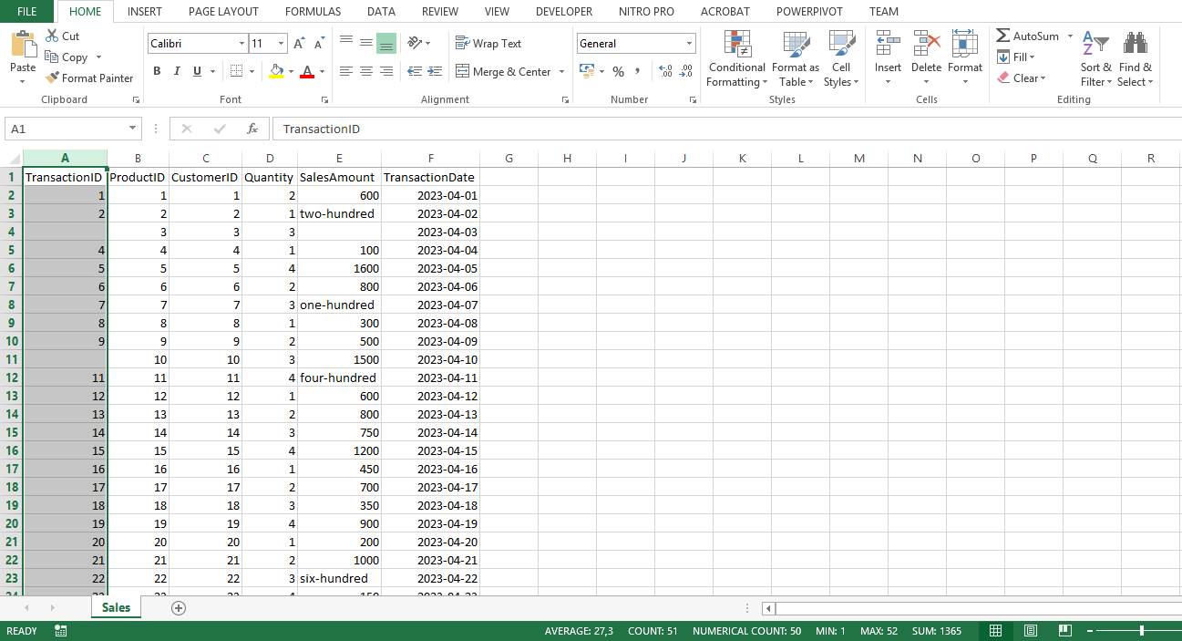
- In Excel on the Data tab, you selected Filter. This enabled filtering for your dataset.
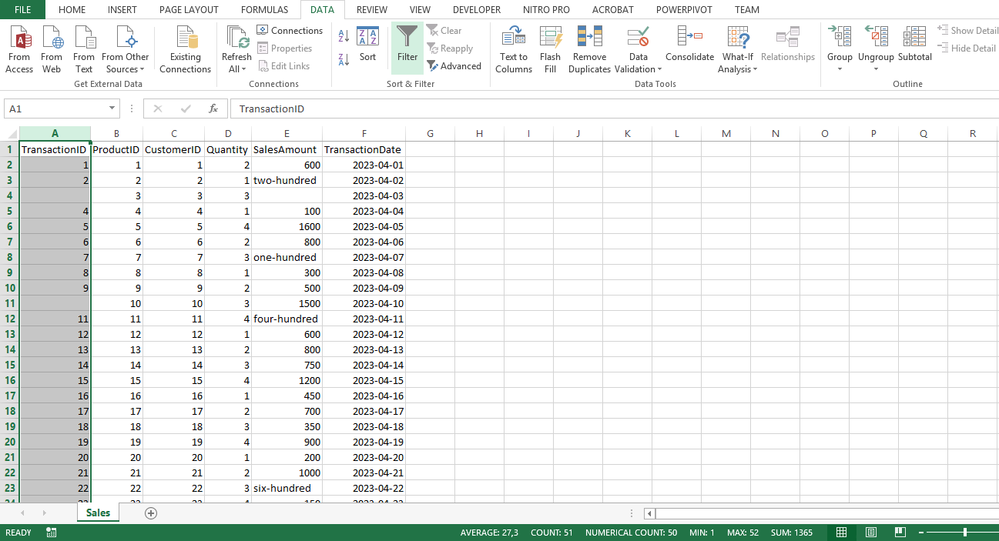
- Selecting the drop-down arrow on the TransactionID column header displayed a menu with several options. You unchecked the box next to Blanks to exclude these entries.
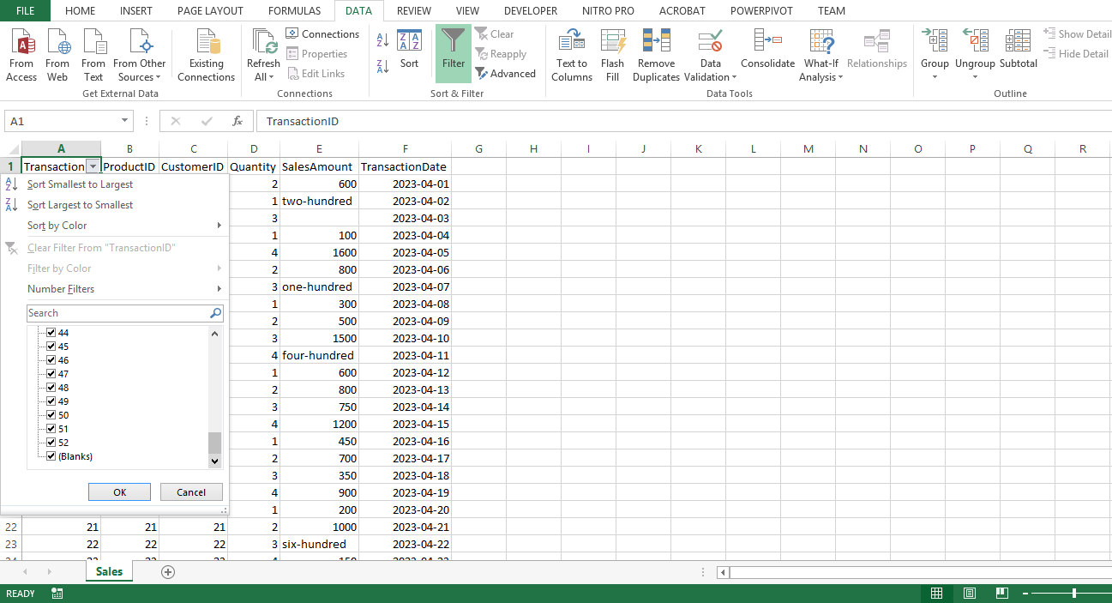
4. Selecting OK applied this filter.
5. Finally, you ensured that all the entries in the column are treated as numerical by setting the data type to Number.
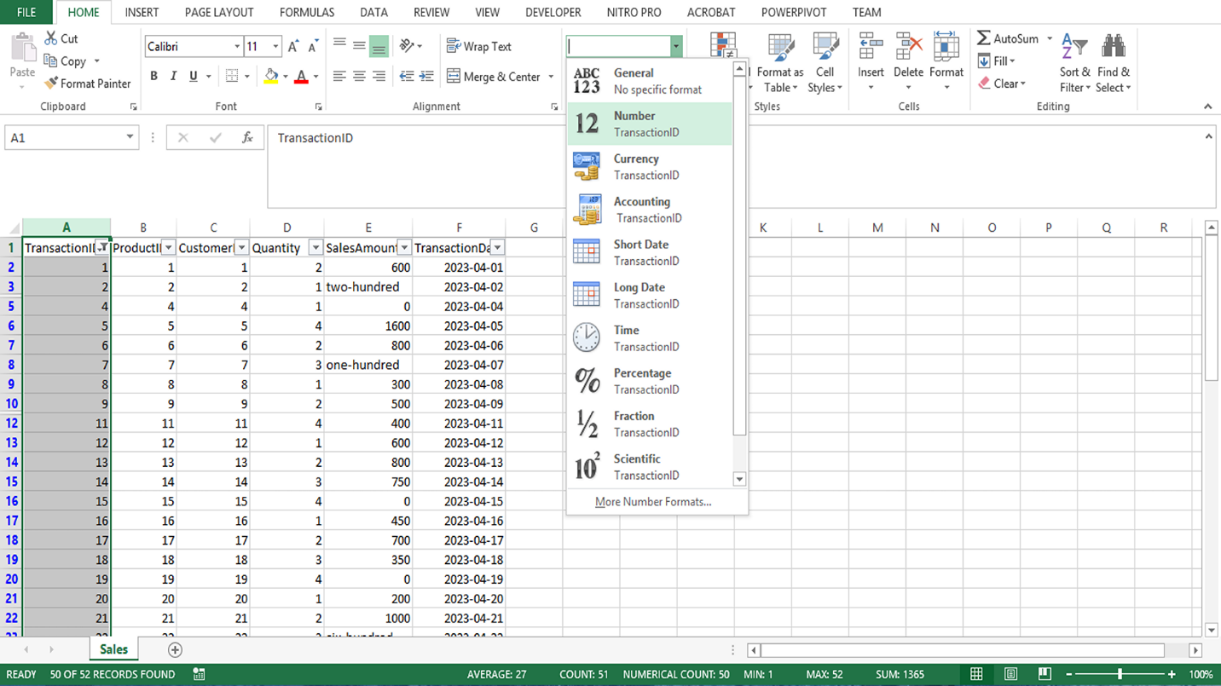

Step 2: Dealing with SalesAmount anomalies
- You encounter anomalies in the SalesAmount column, such as text values in place of numbers or missing values. You selected the SalesAmount column.
- You manually checked the column to identify and replace non-numeric values such as four-hundred. To do this, you double-clicked the cell with the non-numeric value, deleted the existing value, and typed the appropriate numeric value.
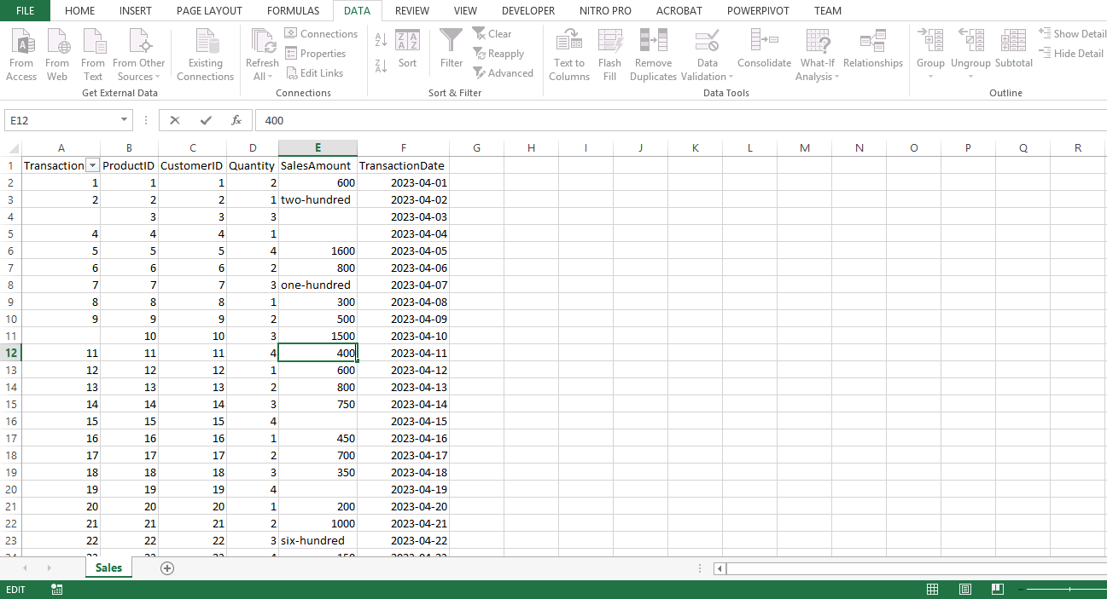
- Next, you replaced any missing SalesAmounts with 0 to prevent the exclusion of these entries from the analysis. To replace null or blank cells with 0, you pressed CTRL + H to bring up the Find and Replace dialog box.
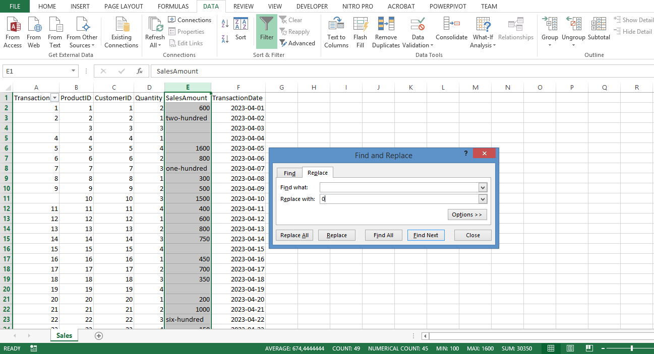
4. You left the Find what field, blank (this was to target all blank cells), and in the Replace with field, you typed 0. You then selected Replace All. The Sales data was then clean and consistent, ready for further analysis in Power BI.
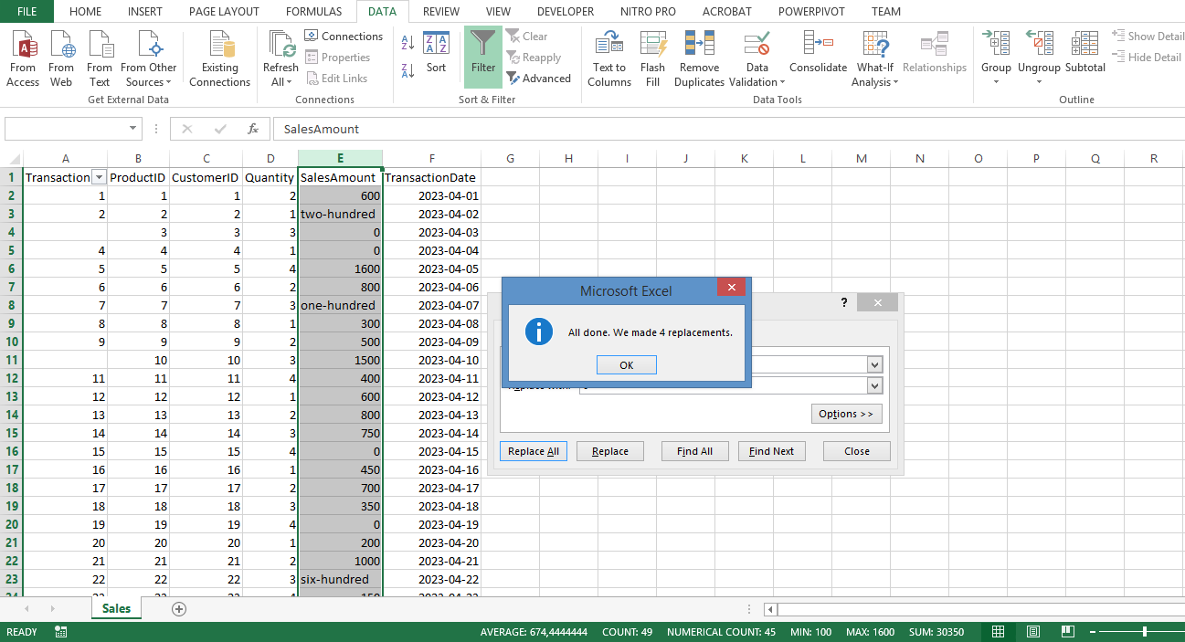

Inventory Dataset: What is the stock level for each bike category?

Step 1: Addressing Missing ProductName
- You began by handling missing ProductNames. Similar to handling missing TransactionIDs in Sales data, you needed to filter out any rows with missing ProductNames, ensuring your analysis only includes complete records. You selected the ProductName column.
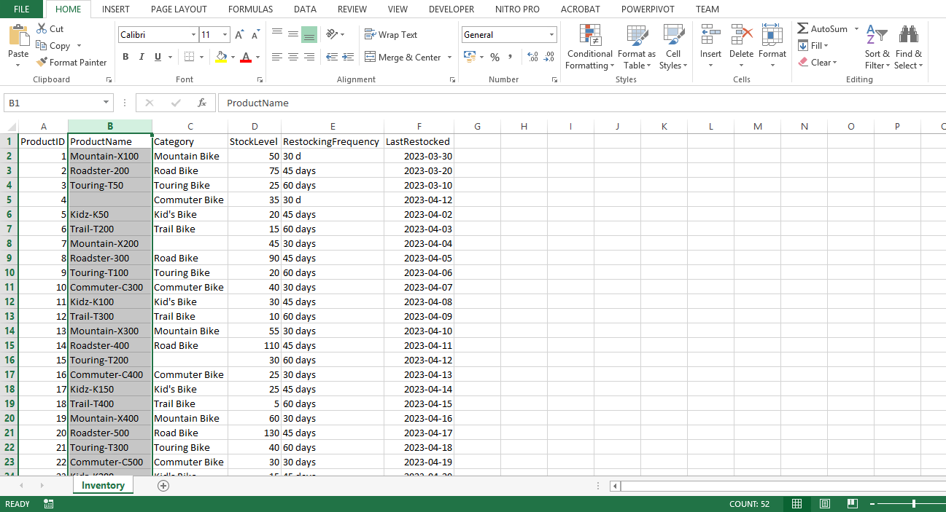
- In the Data tab you selected Filter.
- You selected the drop-down arrow on the ProductName column and deselected Blanks. Then selected OK.
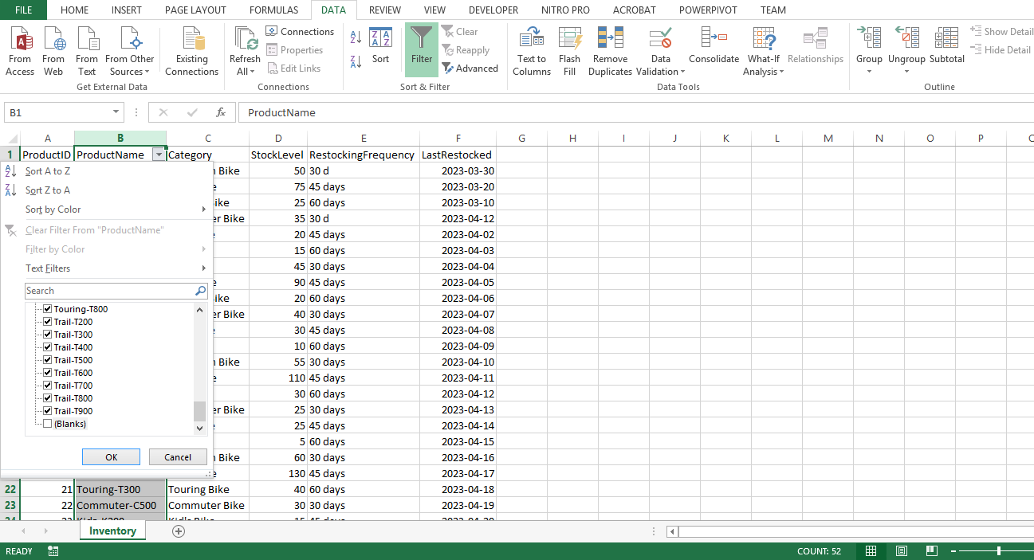

Step 2: Handling missing Category
- Next, you started evaluating the missing Category data, first selecting the Category column.
- You manually checked the column and evaluated the missing entries.
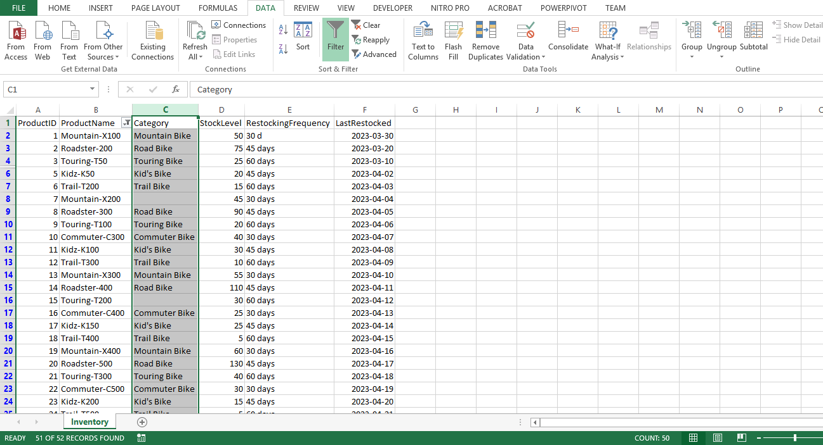
- To replace null or blank cells with No Category Provided, you pressed CTRL + H to bring up the Find and Replace dialog.
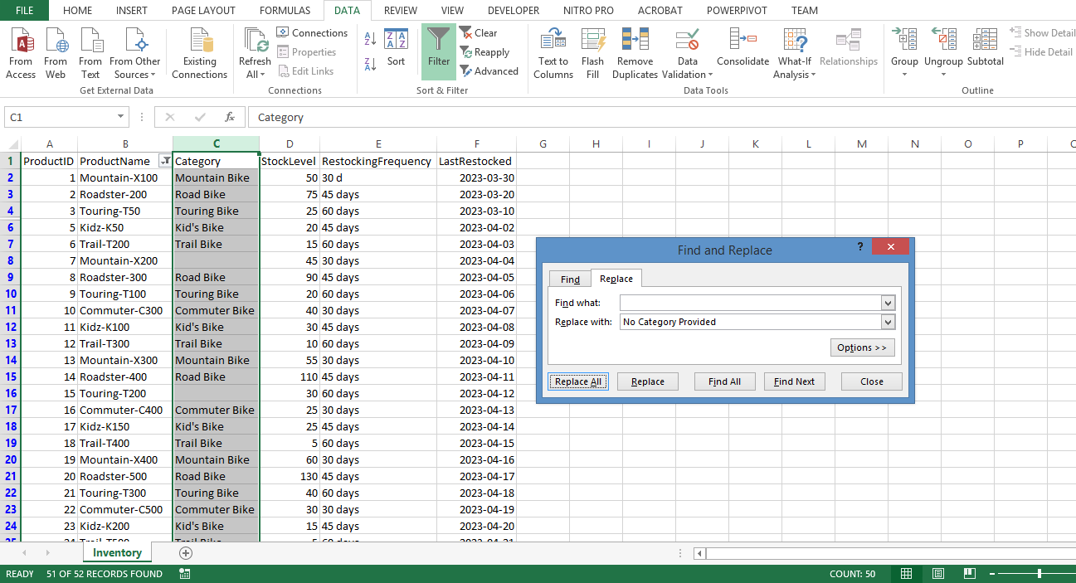
4. In the Find what field, you left it blank to target all blank cells, and in the Replace with field you entered No Category Provided. Then you selected Replace All.
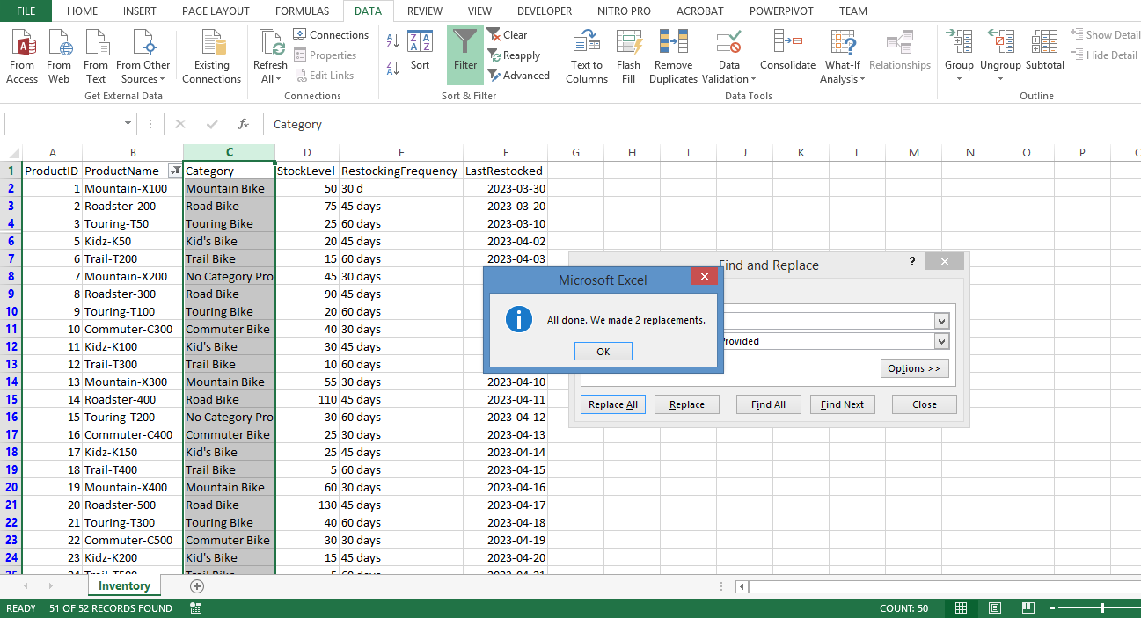

Step 3: Standardizing RestockingFrequency
- Inconsistencies in RestockingFrequency can also hinder accurate analysis. You found the RestockingFrequency column and selected it.
- You pressed CTRL + H to open the Find and Replace dialog.
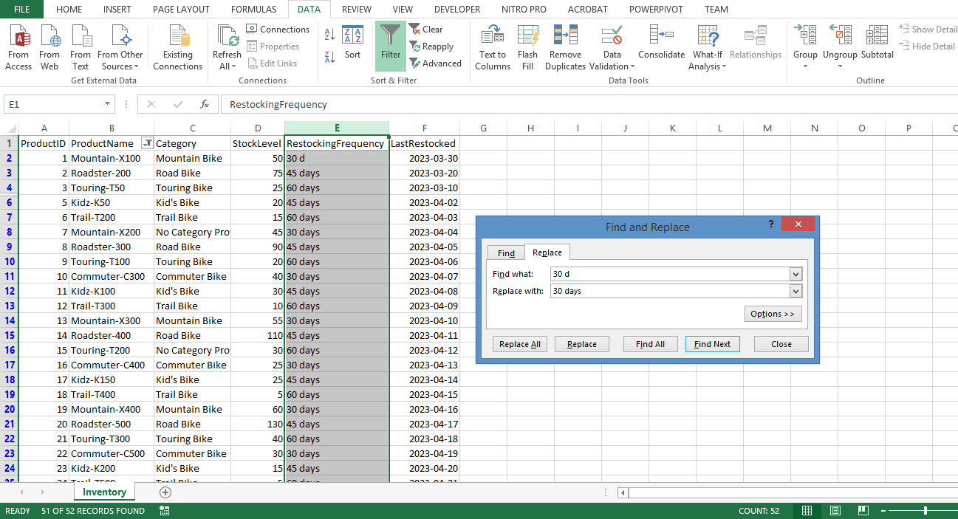
- In the Find what field, you typed 30 d, and replaced it with 30 days.
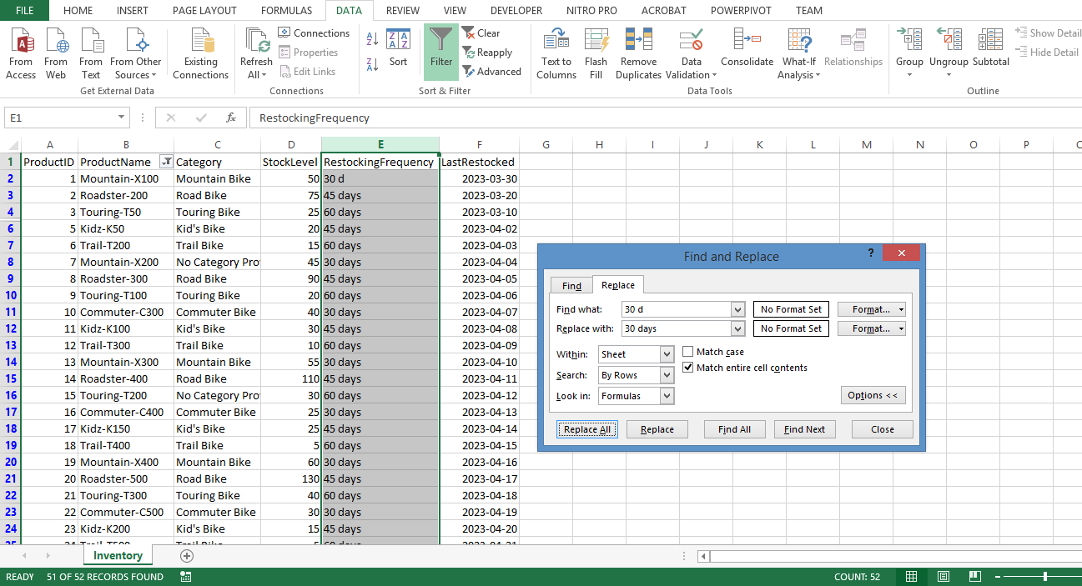
4. Here you expanded the Options menu, and selected Match entire cell contents, and selected Replace All. This step helped to maintain uniformity across data entries. With the Inventory data clean and standardized, when the data is loaded into Power BI you were better able to answer the question: 'What is the stock level for each bike category?'
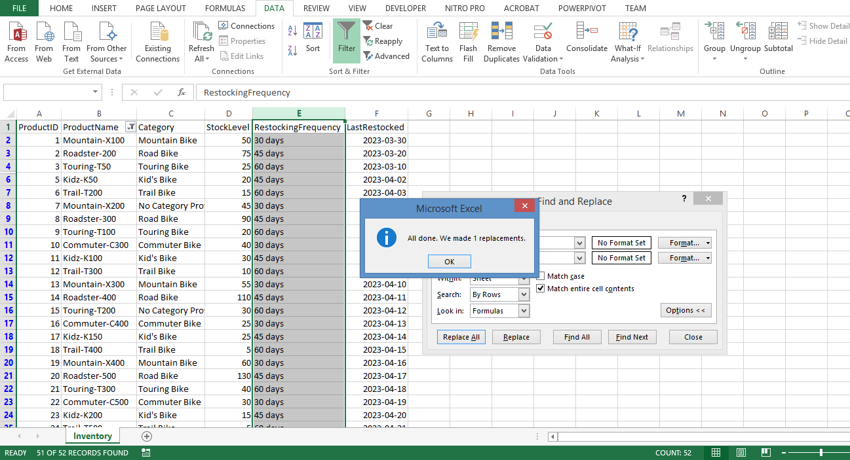

Customer Feedback Dataset: What is the average feedback score for each product?

Step 1: Addressing Missing FeedbackID
- You began by filtering out any rows with missing FeedbackIDs in the Customer Feedback data. Similar to missing TransactionIDs and ProductNames, missing FeedbackIDs can render the corresponding data points anonymous and potentially unreliable. You selected the FeedbackID column.
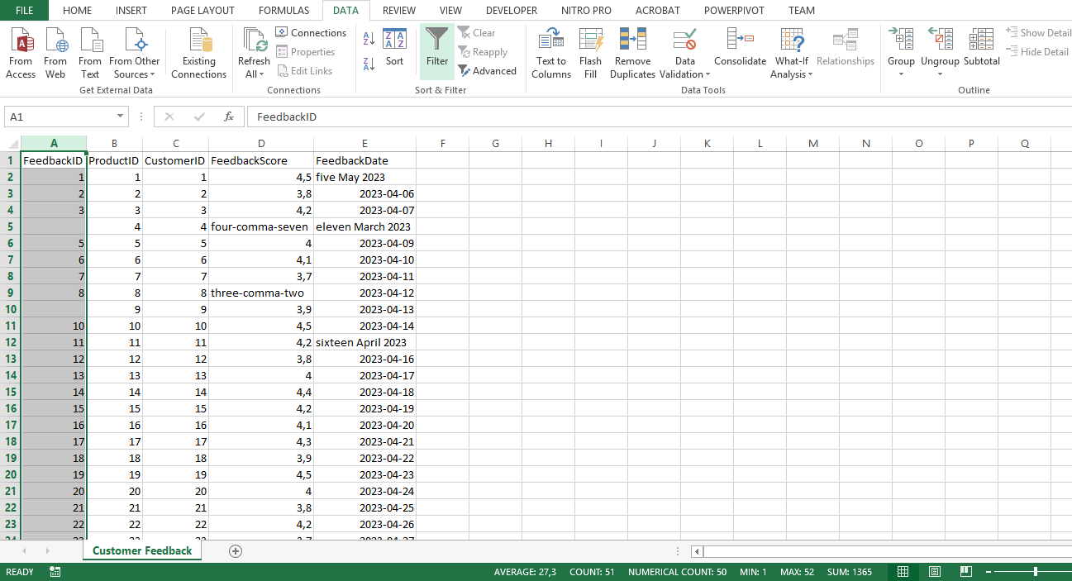
- On the Data tab, you selected Filter.
- Selecting the drop-down arrow on the FeedbackID column you deselected Blanks and selected OK.
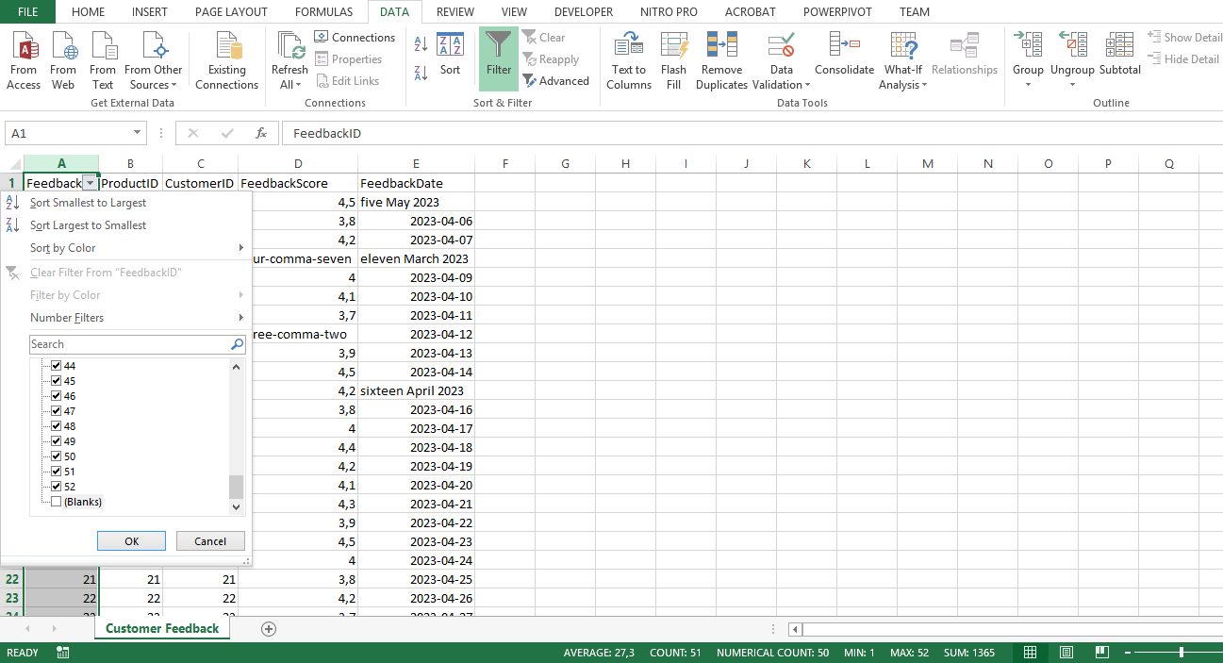

Step 2: Dealing with inconsistent FeedbackScore
- You dealt with inconsistencies in the FeedbackScore column by setting the data type to Number, ensuring all scores were treated as numerical values.
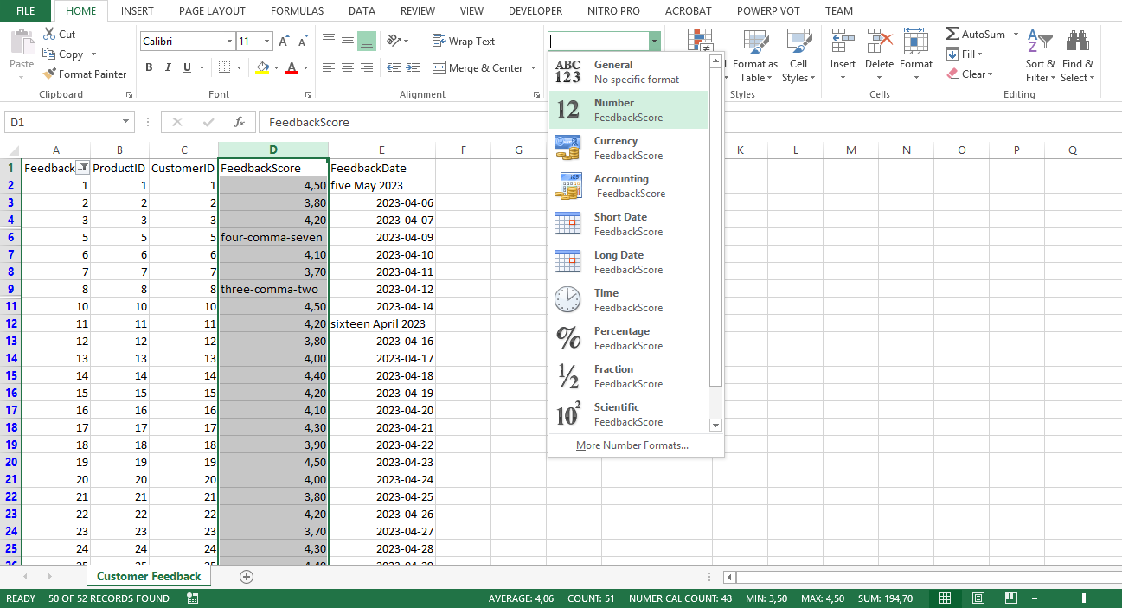
- You manually edited the content of the column to identify and replace non-numeric values. To do this, you double-clicked on the cell with the non-numeric value, deleted the existing value and typed the appropriate numeric value.
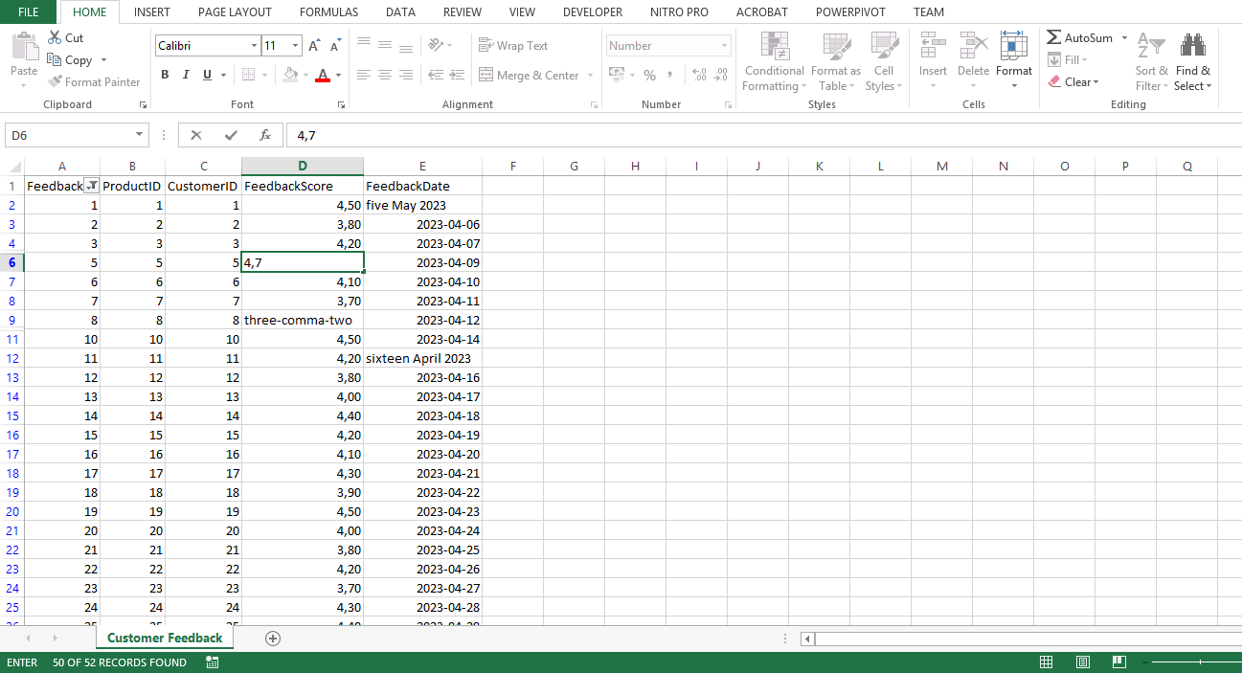

Step 3: Invalid dates in the FeedbackDate column
- Next, you addressed erroneous dates in the FeedbackDate column.
- You selected the FeedbackDate column and set the data type to Date on the ribbon, which forced Excel to interpret all entries as dates.
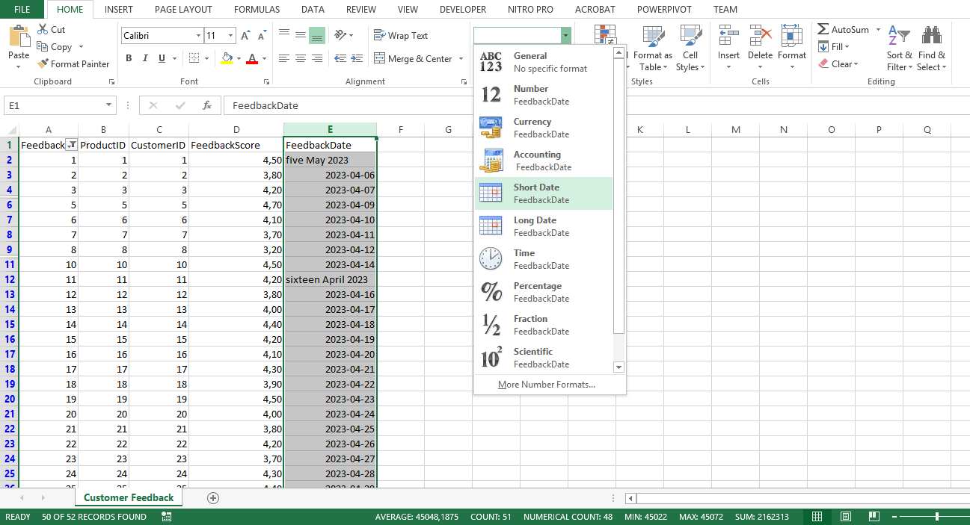
- You then manually identified and replaced non-date values in the column. To do this, you double-clicked on the cell with the non-numeric value, deleted the existing value and typed the appropriate numeric value. Evaluation of the Customer Feedback data was then complete, ready for future analysis in Power BI.
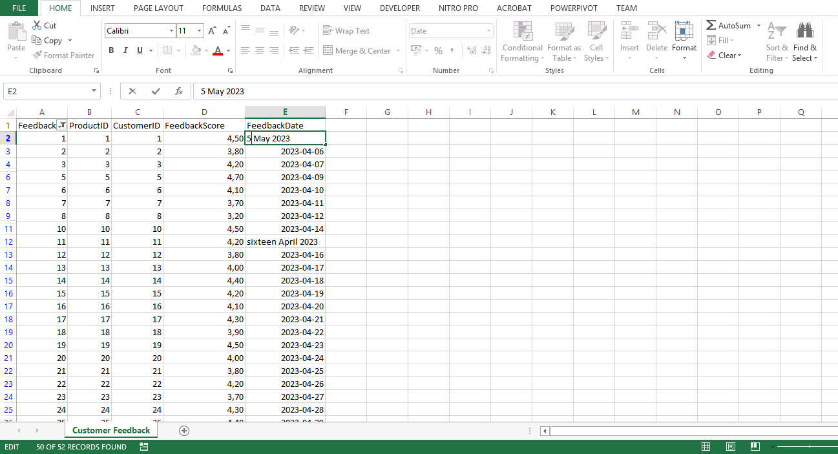
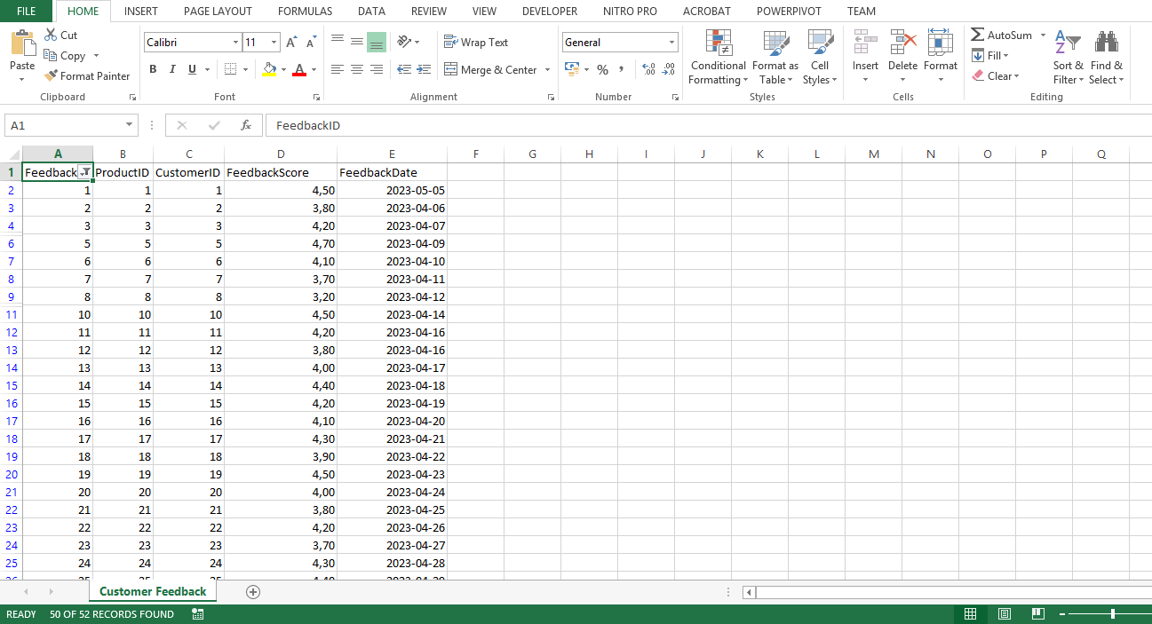

Conclusion
By following these detailed, step-by-step instructions, you have demonstrated proficiency in evaluating data with Microsoft Excel, and preparing the data for further transformation and analysis in Power BI. As you continue working with different datasets and analysis questions, you will become more comfortable with the process and better equipped to draw valuable insights from your data. Keep exploring and pushing your data analysis skills to new heights!

